War: The Card Game

version 1.0

Ehsan Hussain | 12-12-2025

Table of Contents

Introduction 2

Program Background 2

Basic Functionality 2

General Goal 2

Getting Started 3

User Interface Overview 3

Core Features & Functions 5

Changing the language: 5

Changing the music ON/OFF: 6

Setting the names of the players: 6

Choosing to play against the computer or not:: 7

Choosing a specific number of rounds: 7

Troubleshooting 8

Common errors: 8

Appendices 8

Glossary of terms: 8

Additional resources: 8

## 

## Introduction

### Program Background

War is slowly dying, so our goal is to attempt to revive the game towards a new audience. To keep the spirit of the game alive, our application ports the physical game to be easily accessible for any computer and it will include many features keep the user engaged. This desktop application “War: The Card Game” is meant to be a quick game to play when one wants to spend a couple of minutes playing War. With its easy-to-use GUI, anyone of any age can use this software without issues.

### Basic Functionality

Once you start the game, you will be prompted with a choice of playing against the computer or against another player of your choice and a choice to play between five, ten or fifteen rounds. After selecting your opponent and the game’s duration, you will be brought to the actual game of War. The game is to reveal a higher valued card than your opponent’s, because the one with a higher value adds their opponent’s card to their own deck. Your objective is to have more cards than your opponent when time rounds out. When the number of rounds has been completed, the application will prompt the number of cards in every player’s deck and dictate who are the winner and loser of the game based on who ended up with more cards.

### General Goal

We hope that more people will start playing the game and continue to bring the enjoyment of the game, years down the line. This manual is designed to help any user of “War: The Card Game” better understand the application and to hopefully answer most of the questions that one may have in regards to the various functionalities available in this program.

## Getting Started

You must have downloaded and installed Visual Studio to execute this program.

1. In Visual Studio, choose the project “WarCardGameProject”.
2. Open any file.
3. Run the file you have opened.

And there you go! It’s just that simple!

## User Interface Overview

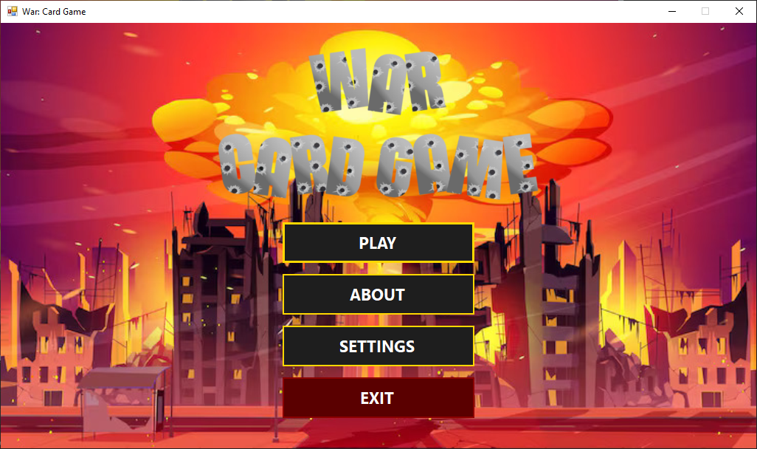

In this form, you will find four buttons. The first will send you to a form to set up the game rules. The second is meant to explain the rules of the game. The third will allow you to configure the language and music of the game to your liking. The last will close the entire program.

This is the form where the rules of the game are explained. There’s only one button and that button closes this form and brings you back to the main menu.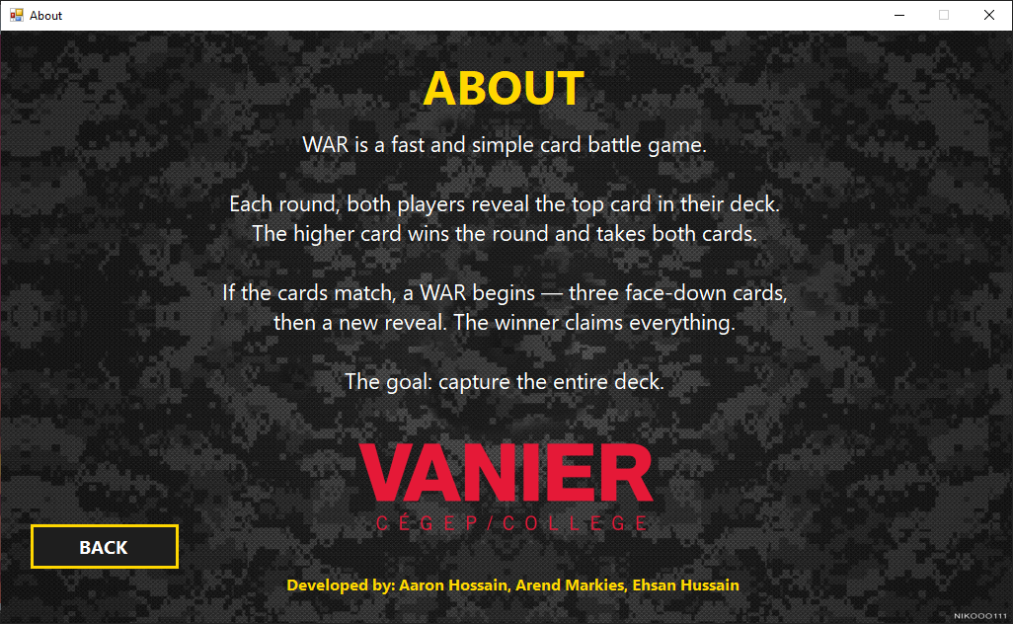

In this form, you can choose if there’s music or not. You can also choose the names of those who will be playing (those names will be displayed during the game). The language can be set between English, French or Spanish. If you made a change that you don’t like, you can either undo it or click the “BACK” button to return without saving your choices. If you do want to save your changes, then you click the “SAVE SETTINGS” button. Either of the buttons at the bottom will bring you back to the main menu.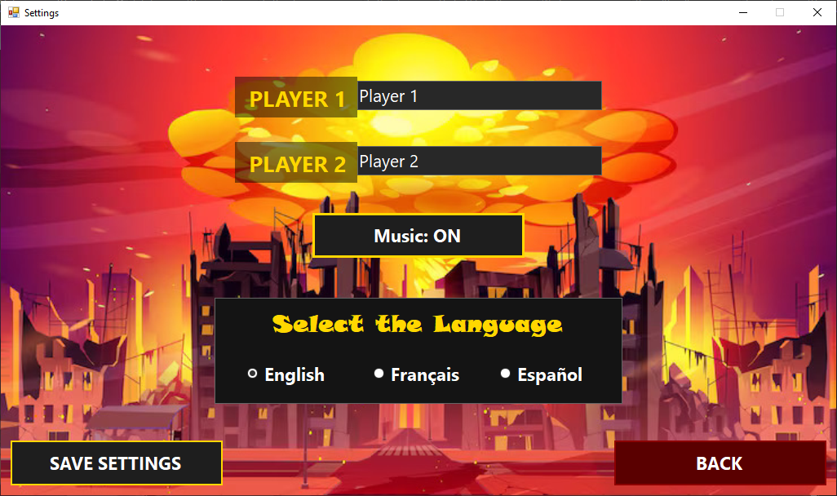

This is where you choose between playing the game against the computer or against another player. You can also decide if you want the game to last 5 turns, 10 turns or 15 turns. If you want to return to the main menu, you click the “BACK” button. If you want to proceed to the game with the configurations you set, then you click the “START” button.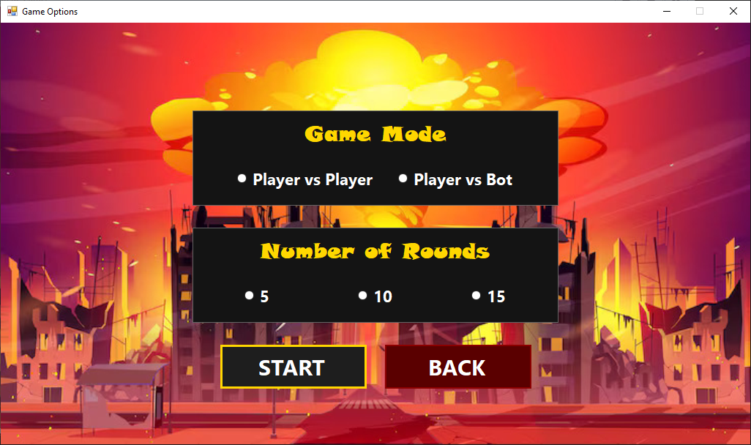

This is where you play the game. The number of rounds left will be displayed at the top As well as the names of the players playing. The cards will be displayed at the center and who wins will be displayed as text in the center of the screen. You can proceed from round to round using the “PLAY ROUND” button. You can revert the game back to the start with the press of the “RESTART” button. You can also return to the main menu with the press of the “MENU” button.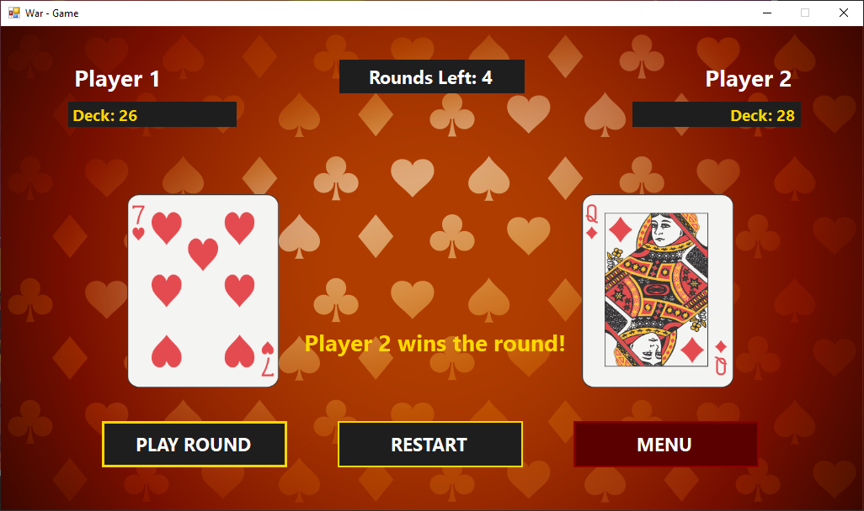

This is where the results of the game are displayed. It will say who won at the top and how many cards each player had at the end of the game. If you press the “RESTART” button at the bottom, you’d be brought back to the options form to pick the settings of the next game. If you press the “MAIN MENU” button, then you’d be brought back to the main menu.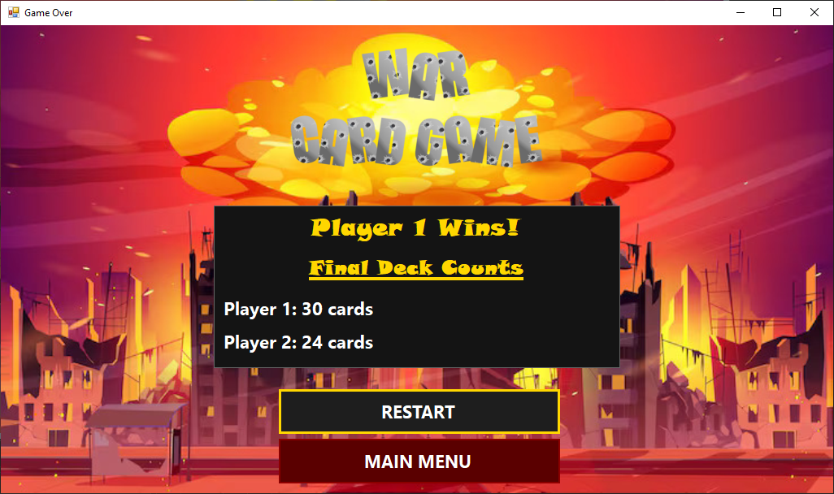

## Core Features & Functions

### Changing the language:

1. If you want to change how the program functions, then you click the “SETTINGS” button of the Main Menu form to be directed to the Settings form.
2. Click one of the language options in the box called “Select the Language”. You can see the language of the text change based on your choice. You can choose between 3 options:

* English (default)
* French
* Spanish

1. Lastly click the “SAVE SETTINGS” button to make sure the changes remain, even after leaving the Settings form.

**Warning**: If you click the “BACK” button, then you will lose all the changes you made in the Settings form.

### Changing the music ON/OFF:

1. If you want to change how the program functions, then you click the “SETTINGS” button of the Main Menu form to be directed to the Settings form.
2. Once you click the middle button, the music will turn off if it was on or it will turn on the music if it was off.
3. Lastly click the “SAVE SETTINGS” button to make sure the changes remain, even after leaving the Settings form.

**Warning**: If you click the “BACK” button, then you will lose all the changes you made in the Settings form.

### Setting the names of the players:

1. If you want to change how the program functions, then you click the “SETTINGS” button of the Main Menu form to be directed to the Settings form.
2. Enter the names you want the players to have in the text boxes at the top.
3. Lastly click the “SAVE SETTINGS” button to make sure the changes remain, even after leaving the Settings form.

**Warning**: If you click the “BACK” button, then you will lose all the changes you made in the Settings form.

### Choosing to play against the computer or not::

1. Head to the options menu by clicking the first button in the main menu.
2. You can choose to play against another player (the option on the top left) or against the computer (the option on the top right).

**Warning**: A choice must be made or else the game will not launch.

### Choosing a specific number of rounds:

1. Head to the options menu by clicking the first button in the main menu.
2. You can choose to play for 5 rounds minimum (the option on the bottom left) or 10 rounds minimum (the option on the bottom middle) or you can choose to play for 15 rounds minimum (the option on the bottom right).

**Warning**: A choice must be made or else the game will not launch.

## Troubleshooting

### Common errors:

You will most likely receive a warning if you try to run a game without setting an opponent or a minimum number of rounds. After clicking “okay”, you will be able to continue setting up the game without issues as long as you don’t leave any of the options empty or else the warning will appear again.

## Appendices

### Glossary of terms:

GUI (Graphical User Interface): Interactable visual components.

Panel: A GUI containing buttons, text and other GUI components.

Terminal: Interface of text-based responses to commands to a program.

Window: Rectangular area on the screen to display applications.

### Additional resources:

If you wish to contact us, our email is 6274100@edu.vaniercollege.qc.ca.